# Research Plan on Quality Factor

$$B∝\frac{{τ\left(m_{S}^{*}\right)}^{3/2}}{m_{c}^{*}κ_{L}}=\frac{μ_{w}}{κ_{L}}$$

* $m_{S}^{*}$ is the Seebeck effective mass
* $m_{c}^{*}$ is the conductivity effective mass
* $μ_{w}$ is the DOS weighted mobility
* $κ_{L}$ is the lattice thermal conductivity
* $τ$ is the electron relaxation time
* $v_{s}$ is the speed of sound

The goal is to maximize the quality factor $B$.

## Seebeck effective mass

### Method 1. Approximation equations

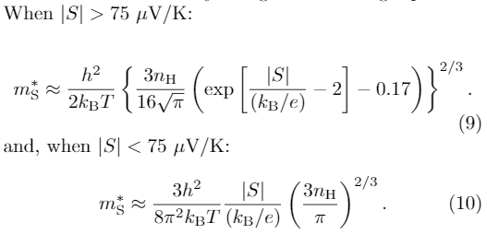

Here $n_{H}$ is the Hall carrier concentration. How to get it? it is not typically reported.

### Method 2. Pisarenko plot

This is essentially the same as Method 1 but averaging more data points

### Method 3. Pymatgen + BoltzTraP?

There is a function called get_seebeck_eff_mass() in pymatgen.

<http://pymatgen.org/pymatgen.electronic_structure.boltztrap.html>

Can we take advantage of pymatgen in this TE study?

Accuracy of BoltzTrap needs to be confirmed at some point.

## Conductivity effective mass

### Method 1. Hall mobility measurement

$$μ∝\frac{{eτ}^{}}{m_{c}^{*}}$$

* $m_{c}^{*}$ is the conductivity effective mass
* $τ$ is the electron relaxation time

This can tell us the effective carrier concentration and effective mobility as a function of temperature.

There are 3 papers in Starrydata2 with keywords “Hall mobility” in the title. All old.

Assuming we have the data, one cant get $m_{c}^{*}$ directly from these measurements!

### Method 2. Pymatgen + BoltzTraP?

There should be a function get_conductivity_eff_mass() in pymatgen.

it is needed for **get_complexity_factor**

or until they add it, it can be deduced from the ratio of complexity factor and Seebeck mass.

<http://pymatgen.org/pymatgen.electronic_structure.boltztrap.html>

Can we take advantage of pymatgen in this TE study?

Accuracy of BoltzTrap needs to be confirmed at some point.

### Method 3. Derive from band structure, transverse & longitudinal effective mass ?

<https://nanohub.org/groups/ece656_f13/File:Notes_on_Effective_Masses.pdf>

Note that these effective masses and DOS options are not directly related to the quality factor as Seebeck and conductivity mass are. Although they could be used to confirm, test for accuracy, self-consistency of Boltztrap.

## Weighted Mobility

$$μ_{w}=\frac{{eτ\left(m_{S}^{*}\right)}^{3/2}}{m_{c}^{*}}$$

* $m_{S}^{*}$ is the Seebeck effective mass
* $m_{c}^{*}$ is the conductivity effective mass
* $μ_{w}$ is the DOS weighted mobility

### Method 2. Electrical conductivity and Seebeck measurement using Approximation equations

There are many papers in Starrydata2 with electrical conductivity and Seebeck vs. temperature plots, e.g., <https://www.starrydata2.org/paperlist/data/599a9785b036dfb17bdd31f9/GeneralDB> (need to log in)

Similar to the approximation equations described above, one can directly get $μ_{w}$!

## Speed of sound

$$κ_{L}∝\frac{1}{v_{s}} or{ κ}_{L}∝\frac{1}{{v_{s}}_{}^{3}}$$

* $κ_{L}$ is the lattice thermal conductivity
* $v_{s}$ is the speed of sound

Get $v_{s}$ from effective elastic constants and density.

We can get elastic tensor from MP.

* $τ$ is the electron relaxation time

$τ$ is also likely to depend on $v_{s}$.